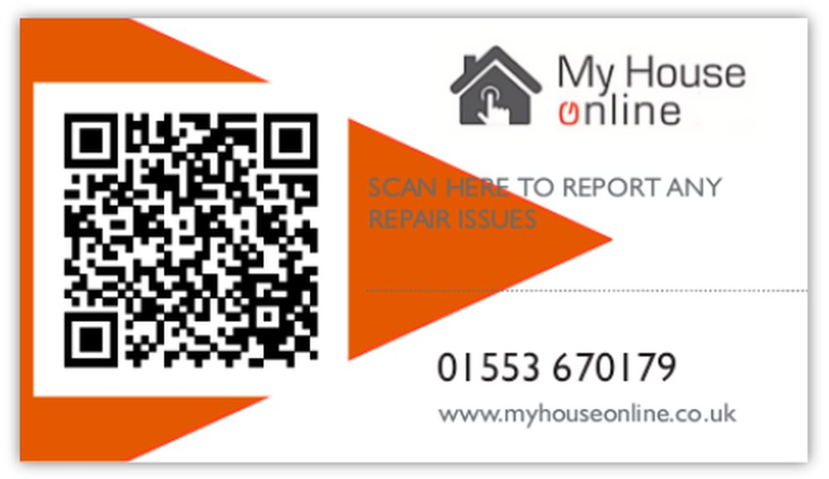
Emergency police or ambulance number 999
Smell gas 0800 111 999
Electricity Emergency number 0800 40 40 90
Wi-Fi Code
There are a number of ways for you to report anti-social behaviour:
- Contact Norfolk Police by calling 101.
- Contact your local district council.
- Social housing tenants can report the problem to their housing officer.
- In an emergency always call the police on 999

Property management: My House Online
Unit 4, Riverside Business Centre, King’s Lynn, PE30 2HD

King’s Lynn 07498 535 195
lettings@myhouseonline.co.uk

Wisbech 07498 842427
property@myhouseonline.co.uk

Office Manager
office@myhouseonline.co.uk

To view all documents, related to this property, scan this code

